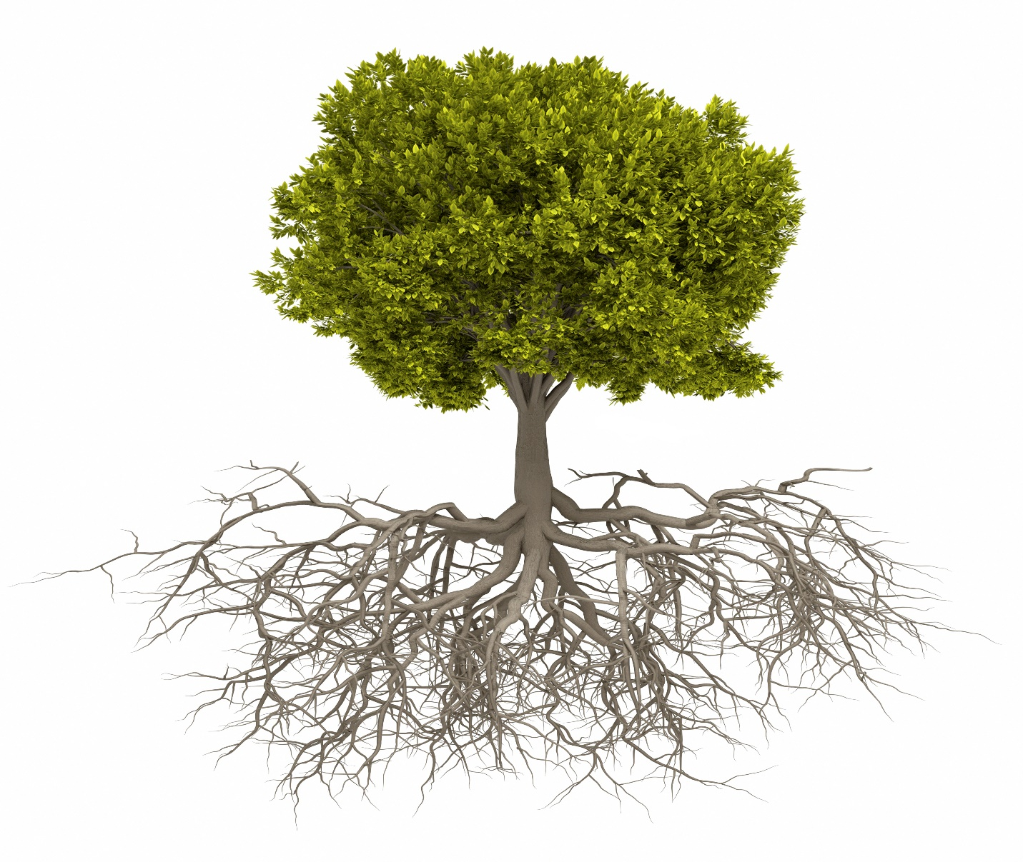
Growing In Oneness
A Strategic Plan for the Ephrata Church of the Brethren
2018 – First Edition

Strategic Planning Team
Scott Johnson Bryan Foard Carol Bowman Brian Messler, Lead Pastor

Leadership Team
Trish Schlegel, Chair Greg Snyder, Vice-Chair Scott Johnson Bryan Foard
Kim Mull Viv Killian Marty Epler Steve Oberholtzer Brian Messler, Lead Pastor

ecob’s Vision/Mission/Purpose/COre Values/Basic Beliefs

And the Lord answered me: “Write the vision; make it plain on tablets, so he may run who reads it. For still the vision awaits its appointed time; it hastens to the end—it will not lie. If it seems slow, wait for it; it will surely come; it will not delay. Habakkuk 2:2-3

Vision

We see the Church, growing in oneness with Jesus Christ and each other, living out the Great Commission, through equipping and supporting the saints.

Mission

CONNECT.GROW.LIVE.RADIATE

We are a family of disciples that seek to connect to, grow in, live out, and radiate the transformative power of Jesus in the world.

CONNECT - 1 Peter 3:8; 1 Corinthians 1:10; Romans 16:17
GROW – Jeremiah 3:15; Philippians 4:19
LIVE – 1 Peter 2:9, Romans 12:2
RADIATE – Mark 16:15; Matthew 28

Purpose

Living with Jesus so other will know Him!

Core Values
- Accountability - Romans 14:12-13; Ezekiel 33:6
  - Holding ourselves and others to do what we say we will do.
- Unconditional Love - Mark 12:30-31; Matthew 5:43; 1 Cor 13:13; Isaiah 43; Romans 5:8; John 13:34-35
  - Love with no hindrances, loving people enough to call them to transformation: has no boundaries, no barriers. Love is not dependent on feelings and means to extend oneself for the well-being of another.
- Compassion - Luke 6:36
  - Being merciful and gentle.
- Sharing Jesus - Matt 28:19-20
  - Show God’s love through action and words with the intention of moving people closer to God in Jesus Christ.
- Prayer – Matthew 6:9-13
  - Talking and listening to God. Walking with God and practicing the discipline of being in His presence.
- Christ Centered - Colossians 1:18; John 14:6; Matthew 25:45
  - Looking to Jesus Christ above ourselves, we model our lives after Jesus Christ. Everything we do is consistent with the character of Jesus Christ as He is the focal point of our lives, what we do, and how we do it.
- Service - Ephesians 6: 6-12; John 13:14-17; Phil. 2:6-11; Romans 12:4-8
  - Using the gifts God gave to further his kingdom, we give up of ourselves to meet the needs of others. Courage to witness for Jesus.
- Worship - Romans 12:1; Ephesians 5:19-20
  - Prayer, connecting, praise meditation, study and service to God.
- Authenticity - Matthew 5:37
  - Reliable, genuine, trustworthy, true, real, the real deal.

Basic Beliefs
- Bible - 2 Tim 3:16, John 1;1, Ps 119:105, Rev 22:18-19
  - Is the word of God that instructs us in faith and living? Is foundation for our beliefs. Is trustworthy
- Jesus - Romans 10:9; Ephesians 2:8 John 14:6: John 3:16, Acts 4:12
  - Only way to salvation by grace. Model for living, how to love, forgive. Teacher, example.
- Prayer - Matthew 6:9-13, Ephesians 6:18; 1 Thessalonians. 5:17
  - Power of Prayer. Talking and listening to God. Cultivating a relationship with God and aligning our hearts with Him.
- Resurrection and its power is available to us - 1 Corinthians 15:13, Matthew 28, John 11:25, Romans 8:11
  - Jesus Rose from Dead - We have power to conquer death and sin in our lives. Defeats sin and death and brings possibility of eternal relationship with God and abundant life.
- John 3:16
  - For God so loved the world that he gave his one and only Son, that whoever believes in him shall not perish but have eternal life.
- Trinity - John 14:26; matt 28:19-20; John 1:1; Galatians 4:6; Gen 1:1
  - God the Father, Son and Holy Spirit.

Strategic Plan

Mission Targets
- Connect - Fellowship/Ministry
  - Encourage the congregation to focus on those activities that support fostering / growing authentic, intimate relationships with our God, between congregation members of ECOB, the communities we live in, and in the regional ecumenical communities
- Grow - Discipleship/Welcoming
  - Equipping the congregation, at all life stages, to focus on activities that orient us toward developing existing believers into deeper discipleship, education and implementing a personal call with a purpose. Educational and experiential focused.
- Live - Stewardship/Worship/Leadership
  - Empower our congregation to focus on practical opportunities to implement day to day Biblical principles in order to maximize Kingdom impact
- Radiate - Evangelism/Missions
  - Energize our congregation to focus on opportunities to share and live out their faith locally, nationally, and globally

Mission Goals
- Connect
  - Deepen relationships within our congregation, heritage, and ecumenical communities
  - Discover and encourage the use of ECOB’s gifts, talents, and time
  - Develop opportunities to share the mission/vision/values of ECOB with the congregation and community
- Grow
  - Develop “on ramps” in order to integrate those who are new to ECOB
  - Encourage a deeper personal investment of discipleship across all age groups and life stages
  - Create and enhance opportunities to care for and support the ECOB family (maybe might better be listed as
- Live
  - Steward ECOB’s structures, facilities, and finances for the greatest kingdom impact
  - Equip, encourage, and empower lay leaders and staff towards a deeper level of ministry effectiveness.
  - Focus on ways that we can live out healthy and holistic spiritual disciplines
- Radiate
  - Discover a deeper sense of faith sharing in our congregation and community
  - Create, enhance and expand local, national, and global missions

Mission Initiatives

CONNECT

Deepen relationships within our congregation, heritage, and ecumenical communities

INITIATIVES | STAFF/TEAM
1.1.1 Congregation – Create opportunities for various age groups, ministry/life groups, and life stages within our congregation to participate in connect events that specifically encourage fellowship within the body. | Carol  Connections Team
1.1.2 Congregation – Provide opportunities that allow us to celebrate what Jesus is doing in our midst and in the life of our community and congregation. (testimonies, online, print) | Carol  Communications Team
1.1.3 Congregation – Enhance and create opportunities for better congregational communication | Carol  Communications Team
1.1.4 Heritage – Hold a 4-6-week elective class connected to themes within our heritage every 2 years | Rob
1.1.5 Heritage – Support COB missions locally, nationally, globally through finances, communication, and active participation | Brian  Leadership Team
1.1.6 Heritage – Preach about our heritage – either in a series or making sure preachers use learnings from our heritage within their sermons | Brian  Preaching Team
1.1.7 Ecumenical – Develop at least one opportunity/year that will engage the ecumenical community to a greater sense of unity | Brian  Leadership Team
1.1.8 Ecumenical – Partner with one church/year to pray together and for one another | Brian  Leadership Team
1.1.9 Ecumenical – Become more engaged in the life of the Ephrata Ministerium (participating in meetings and events) | Brian  Leadership Team

1.2 Discover and encourage the use of ECOB’s gifts, talents, and time

INITIATIVES | STAFF/TEAM
1.2.1 Hold a yearly gift discovery class (SHAPE or something similar) | Sharon  SHAPE Team
1.2.2 Create a database that has all the gifts/passions/talents of those in the congregation in a location that can be accessed by congregational leadership and staff | Carol  Connections Team
1.2.3 Provide opportunities for all age groups to serve in the life of the congregation | Carol  Connections Team
1.2.4 Identify individuals in the ECOB community who God may be calling to ministry/ordination | Brian  Personnel Team
1.2.5 Celebrate members who have gone above and beyond in their service to Christ and the church | Carol  Connections Team

Develop opportunities to share the mission/vision/values of ECOB with the congregation and community

INITIATIVES | STAFF/TEAM
1.3.1 Develop and enhance communication tools to share the news/mission/vision of Jesus’s work at and through ECOB (online, print, news, banners, mission moments, graphics or visuals around the church, invite cards, mailings, yard signs, float in parade, etc.) | Carol  Communications Team
1.3.2 Utilizing the church facility, create visuals that share the vitality of ECOB | Rob  Front Line Team
1.3.3 Preach and have classes dedicated to sharing this goal | Brian  Preaching Team

GROW

develop “on ramps” in order to integrate those who are new to ECOB

INITIATIVES | STAFF/TEAM
2.1.1 Deepen our partnership with the Children’s Center through implementing various “touch points” with that mission | Sarah  Children’s Center Standing Committee
2.1.2 Encourage a deeper sense of welcome in the life and ministries of ECOB | Rob  Front Line
2.1.3 Develop a pathway from guest to member – outlining specific goals and needs along the way – creating a deeper level of engagement from various teams and the congregation | Rob  Front Line  (Carol and Connections)
2.1.4 Enhance and expand our Front-Line ministry | Rob  Front Line

2.2 Encourage a deeper PERSONAL INVESTMENT of discipleship across all age groups and life stages

INITIATIVES | STAFF/TEAM
2.2.1 Create a Discipleship Pathway from birth - death | Rob
2.2.2 Enhance and expand KidMin | Lindsay  KidMin Team
2.2.3 Create a Young Adult ministry | Ryan  Young Adult Team
2.2.4 Enhance and expand Student ministry | Ryan  Student Ministry
2.2.5 Celebrate milestones in both spiritual and personal lives – encouraging congregation to document these celebrations | Rob  Discipleship Pathway Team
2.2.6 Develop a weekday ministry that brings the congregation together in order to live out our mission statement (i.e. connect.grow.live.radiate) – included in it (meal, discipleship options, musical options, support groups, etc.) | Rob  Jericho Ministry Team
2.2.7 Hold or participate in “Emmaus” (or similar) opportunities | Dean  Spiritual Discipline Team
2.2.8 Develop more one on one opportunities for discipleship (accountability partners, mentoring programs) | Rob  Deacons Team
2.2.9 Create regular opportunities to experience elements of our mission (connect.grow.live.radiate) for the purpose of transformation in Christ. | Brian  Staff Team

2.3 Create and enhance opportunities to care for and support the ECOB family

INITIATIVES | STAFF/TEAM
2.3.1 Utilizing life groups – train leaders in discovering ways in which their groups can provide care for its participants | Sharon  Life Group Ministry Team
2.3.2 Create a lay-care team that will call/visit/text/email congregation members as a supplement to deacons and pastors | Rob  Deacon Team
2.3.3 Provide caring opportunities at various points in a person’s life (support new moms/birthday celebrations/death/surgeries) | Rob  Deacon Team
2.3.4 Develop a process for knowing when people are coming to and leaving the church | Cindy
2.3.5 Create opportunities for prayer and healing throughout the year | Kim  Spiritual Discipline Team

Live

3.1 Steward ECOB’s Structure, facilities, and finances for the greatest kingdom impact

INITIATIVES | STAFF/TEAM
3.1.1 Update our current facilities to engage both congregation and community needs (reworking office space, separate space for KidMin, open spaces for gathering/fellowship, repurpose gym for alternate use, etc.) | Brian  Building Team
3.1.2 Encourage a deeper sense of generosity through preaching, teaching, print and electronic means | Brian  Finance Team
3.1.3 Partner with local organizations to develop a utilization plan for ECOB facilities | Cindy  Trustees
3.1.4 Shore up our financial policies and procedures | Brian  Finance Team
3.1.5 Continue to monitor and adapt ECOB’s structure so that if fits our current needs and vision for the future (gifts discernment, personnel, leadership, teams, etc.) | Brian  Leadership Team
3.1.6 Create facilities, structures, and ministries that provide for the safety of all ages | Brian  Leadership Team
3.1.7 Connect, evaluate, and implement all ECOB ministries under one umbrella strategy utilizing our mission statement – connect.grow.live.radiate | Brian  Leadership Team

3.2 Equip, encourage, and empower lay leaders and staff towards a deeper level of MINISTRY effectiveness

INITIATIVES | STAFF/TEAM
3.2.1 Develop quarterly training/retreat opportunities for staff | Brian  Personnel Team
3.2.2 Create a yearly, week of ministry assessment with staff and Leadership Team | Brian  Personnel Team
3.2.3 Coordinate yearly training events for those taking on new roles in the life of the church (teachers/youth leaders/KidMin/life groups/mission leaders, Safe Church, etc.) | Carol
3.2.4 Provide a reporting structure for this strategic plan | Brian  Strategic Planning Team
3.2.5 Encourage and support ECOB staff to set and implement spiritual, physical, mental, and emotional yearly goals | Brian  Personnel Team
3.2.6 Evaluate, discern, and implement a strategy moving ECOB from a Staff Led/Staff Driven Structure to a Staff Driven/Lay Led Structure | Brian  Leadership Team

3.3 Focus on ways that we can live out healthy and holistic spiritual disciplines

INITIATIVES | STAFF/TEAM
3.3.1 Expand music opportunities for children, youth, and adults – vocal, instrumental, various groups | Dean  Worship Ministry Team
3.3.2 Deepen the congregation’s awareness of spiritual disciplines | Dean  Spiritual Discipline Team
3.3.3 Hold 6 non-Sunday worship services a year (men’s and women’s worship services – 2 each, 2 other services of choice – possibly healing service, prayer service, Taize service, etc.) | Dean  Worship Ministry Team
3.3.4 Develop a team of lay-leaders to help in the Sunday morning worship ministry | Dean  Worship Ministry Team
3.3.5 Develop a ministry that encourages and supports peacemaking and reconciliation | Rob  Team – TBD
3.3.6 Discover and implement ways in which we can carry the message of the weekend into every day of the week (Sermon follow up, discussion groups, FB, blogs, etc.) | Carol  Communications

Radiate

4.1 Discover a deeper sense of faith sharing in our congregation and community

INITIATIVES | STAFF/TEAM
4.1.1 Hold “Bridging the Gap” retreat/classes to encourage people to share their faith | Brian  BTG Team
4.1.2 Create quarterly events that provide opportunities for congregation members to share their faith with the community | Brian  BTG Team

4.2 Create, enhance and expand local, national, and global missions

INITIATIVES | STAFF/TEAM
4.2.1 Identify partnerships - locally, nationally, and globally, that will encourage missional participation from ECOB individuals, families, and groups | Brian  Missions Teams
4.2.2 Local – Hold 2 events/year that create opportunities to serve the community | Brian  Lovephrata Team
4.2.3 Local – Start a welcome to the neighborhood process | Rob  Front Line Team
4.2.4 Local – Deepen ECOB’s relationship with local schools, their staff, families, and students through various “touch points” and ministries. | Ryan  Family Ministries
4.2.5 National – Promote national mission trips (BDM, Workcamps) | Brian  National Mission Team
4.2.6 National – Support national ministries through prayer and finances | Brian  National Mission Team
4.2.7 Global – Hold at least one global mission trip/year with the focus on developing relationships with communities rather than a “hit and run” model | Brian  Global Missions Team
4.2.8 Global – Provide support to those serving globally through prayer, finances, and communication | Brian  Global Mission Team

